Activity 2 Documentation Sept 8, 2025
Output Webpage 100% Zoom

Header to Profile Section
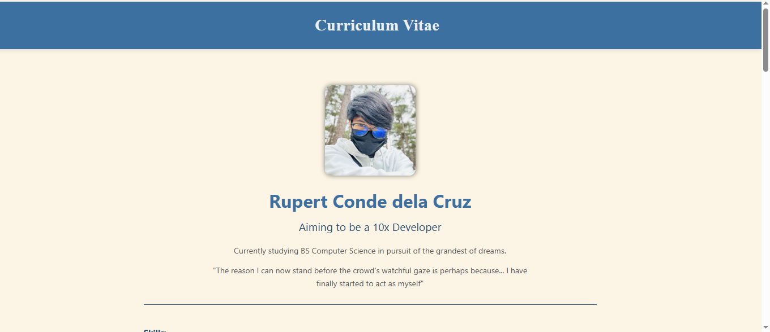
Skills to Experience Section
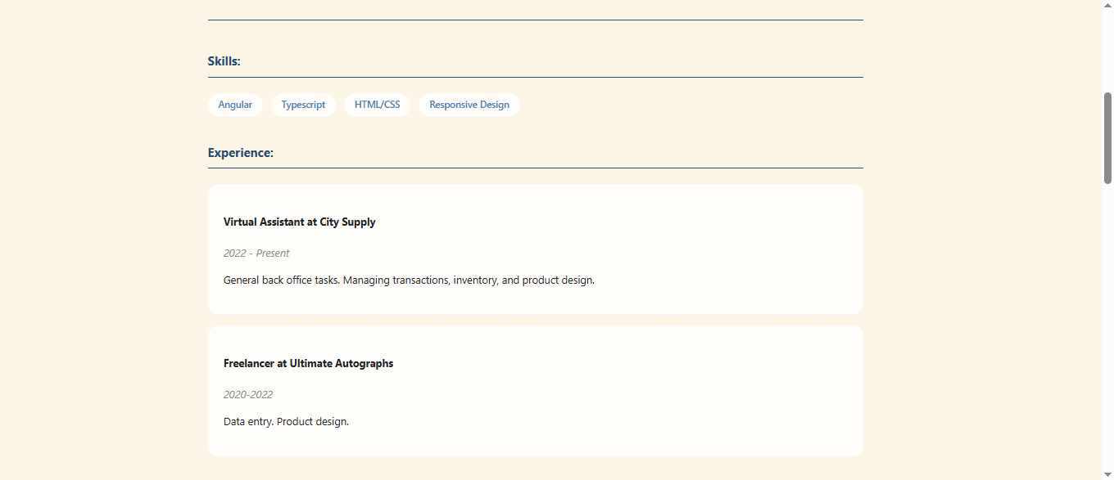
Education Section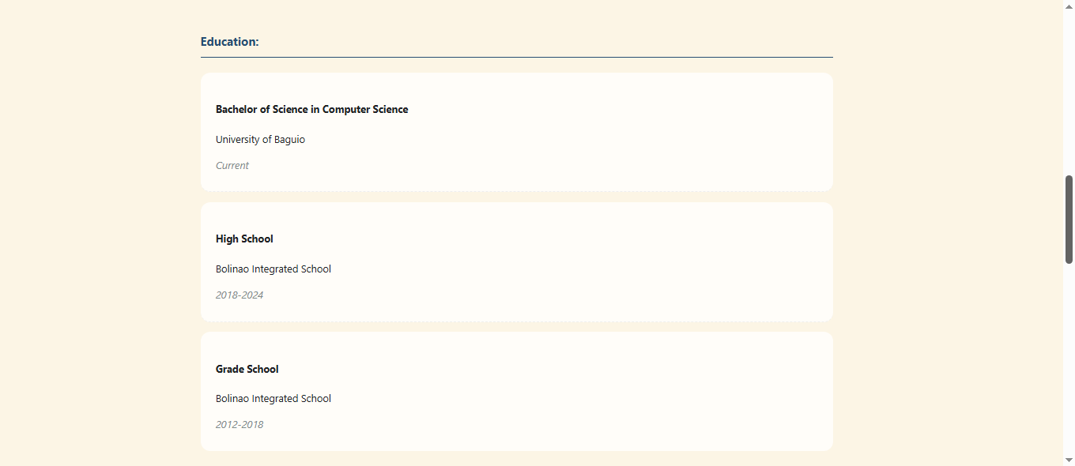

Academic Awards
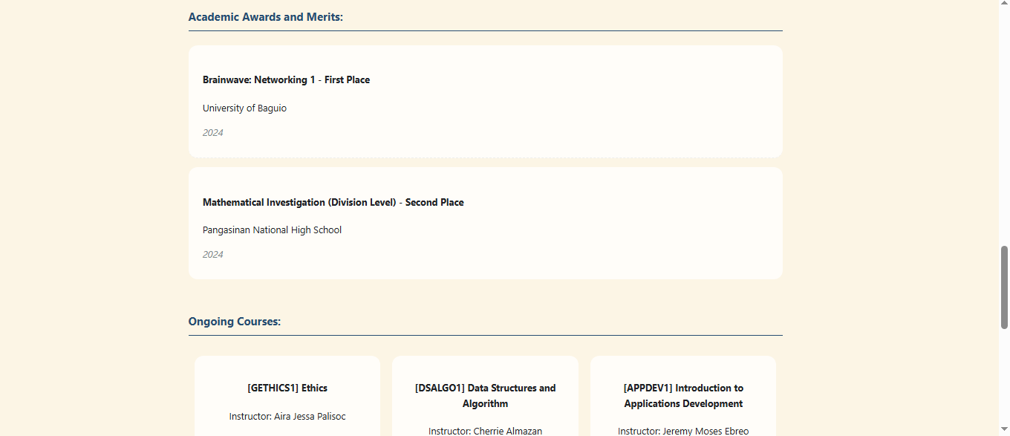
Ongoing Courses
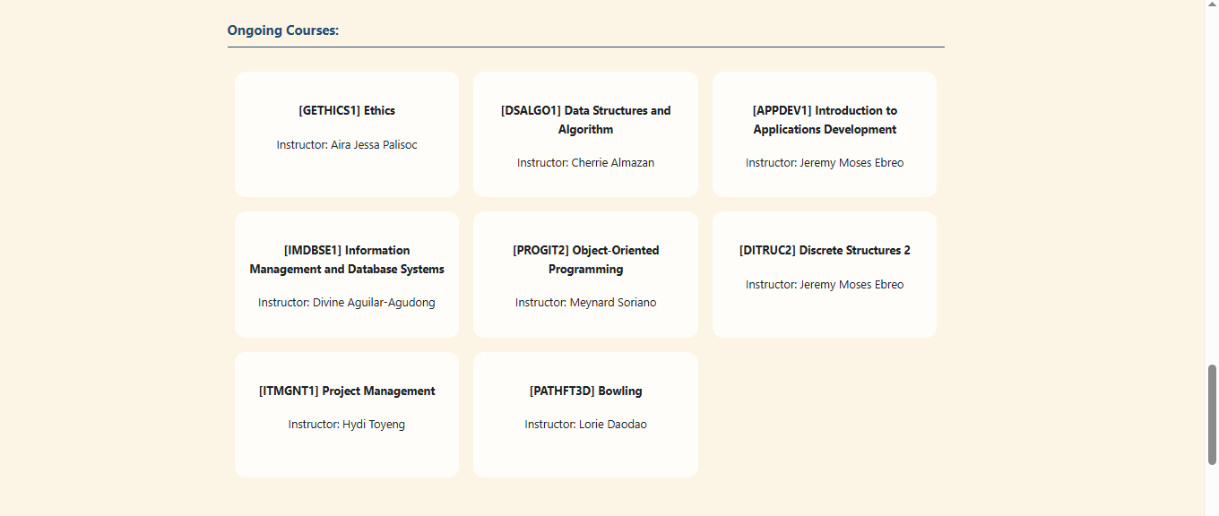
Contact and Footer Section
